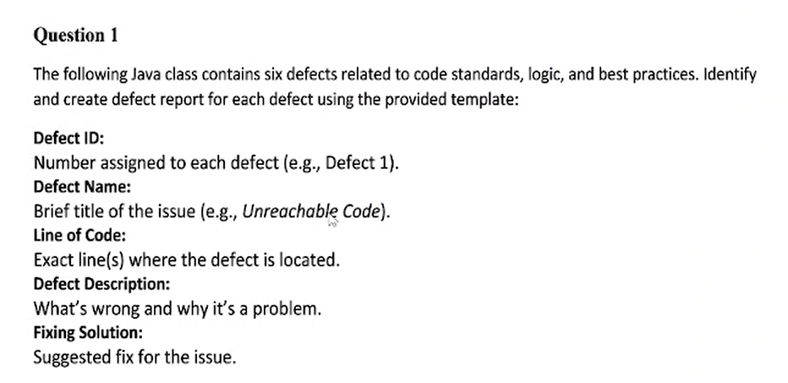

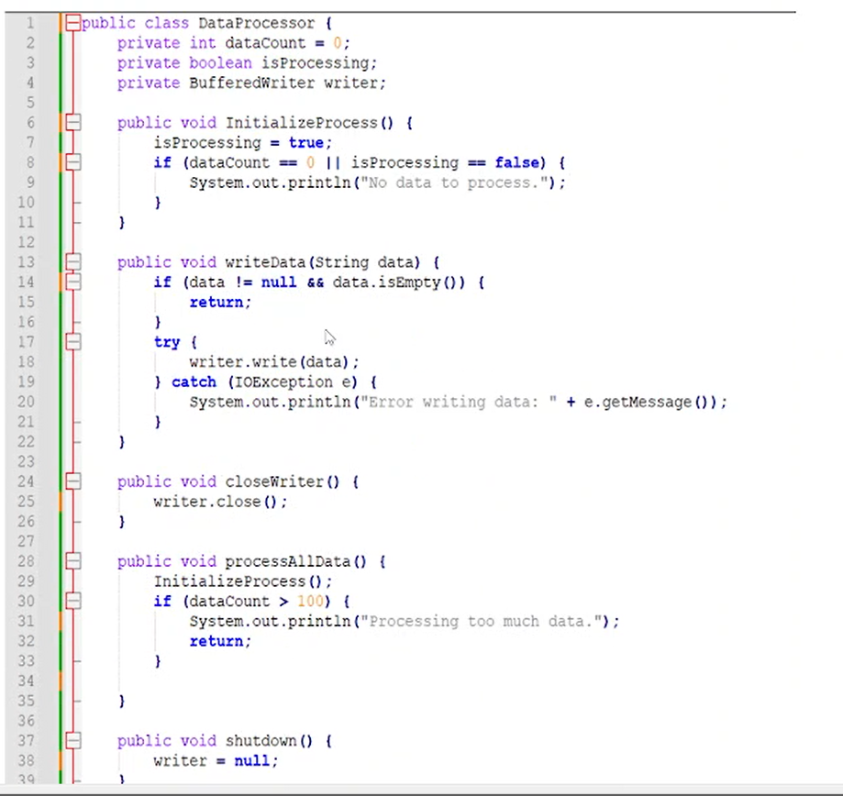

**Defect ID: defect 1**

**Defect Name: invalid isProcessing logic**

**Line of Code: 8**

**Defect Description: isProcessing is set true before check in condition**

**Fixing solution: isProcessing = true move to end of function**

**Defect ID: defect 2**

**Defect Name: No check null for writer**

**Line of Code: 18**

**Defect Description: writer is null then write method can not be used ( it throw exception)**

**Fixing solution: isProcessing = true move to end of function**

**Defect ID: defect 3**

**Defect Name: No try catch when work with file**

**Line of Code: 25**

**Defect Description: an error syntax , when work with file**

**Fixing solution: use trycatch for writer.close()**

**Defect ID: defect 4**

**Defect Name: No try catch when work with file**

**Line of Code: 25**

**Defect Description: an error syntax , when work with file**

**Fixing solution: use trycatch for writer.close()**

**Defect ID: defect 5**

**Defect Name: not import IOexception**

**Line of Code:**

**Defect Description:**

**Fixing solution:**

**Defect ID: defect 6**

**Defect Name: datacount not change in processData**

**Line of Code: 41-44**

**Defect Description: if condition never true if data count not change**

**Fixing solution: add if (datacount <100 ) datacount ++;**

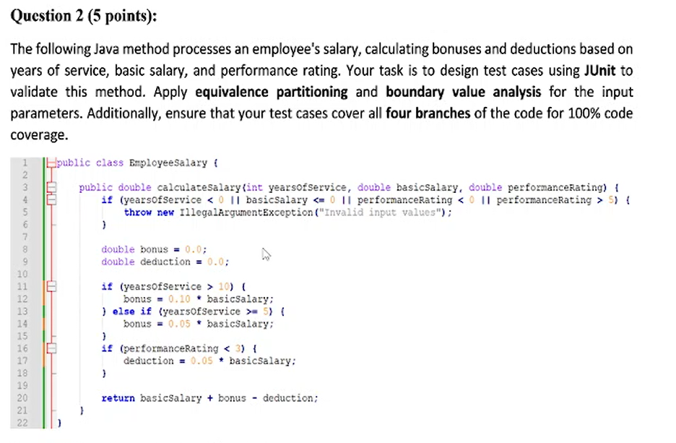

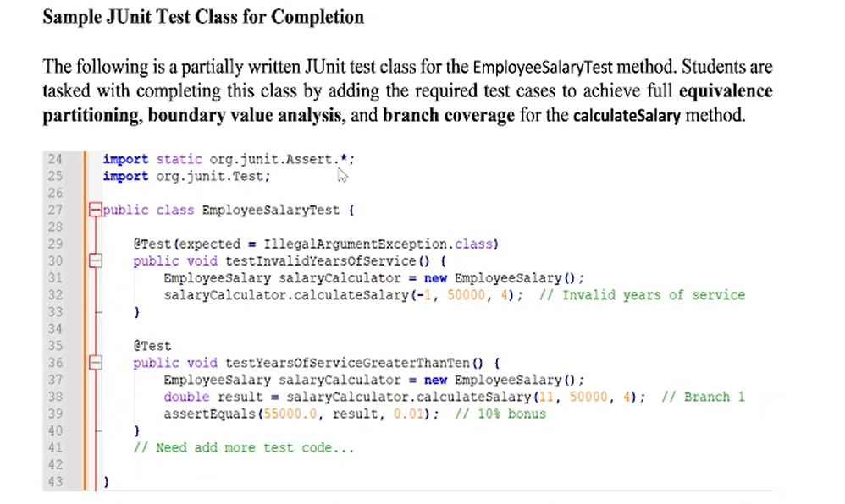

**Q3:**

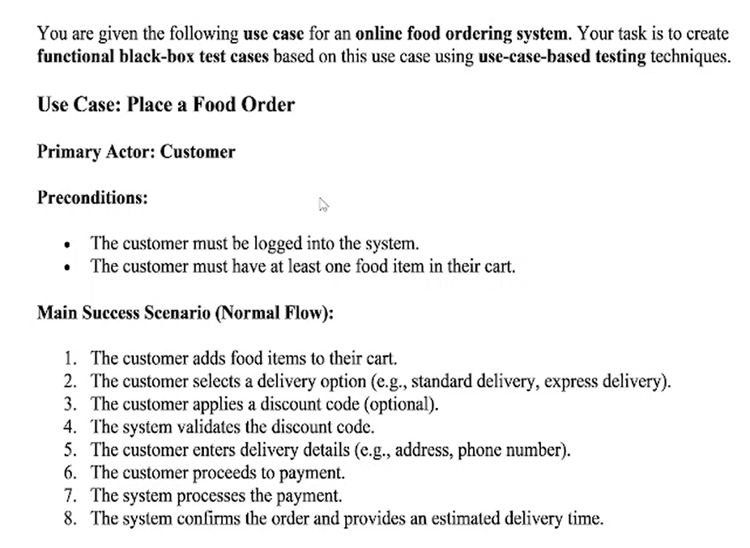

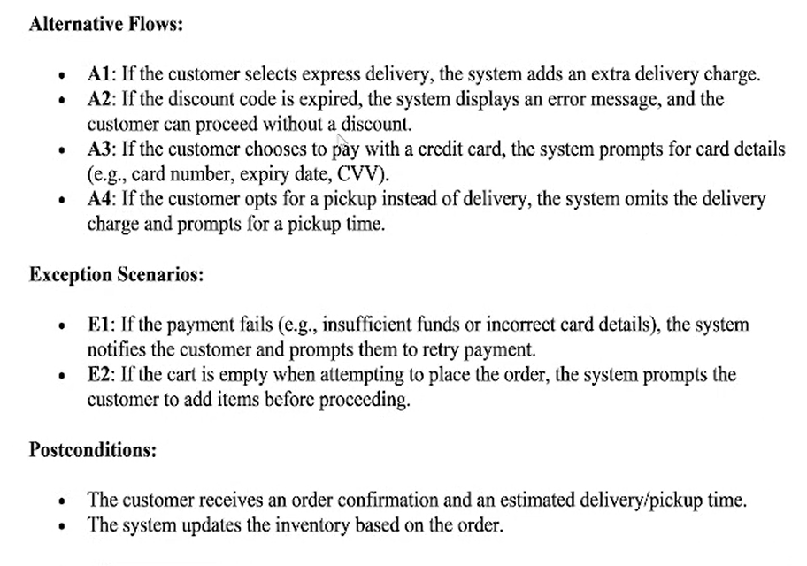

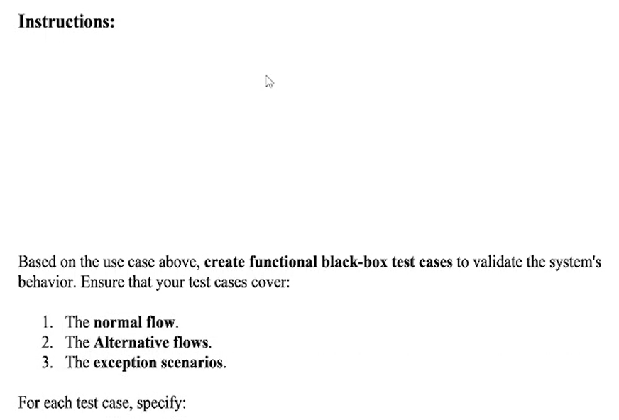

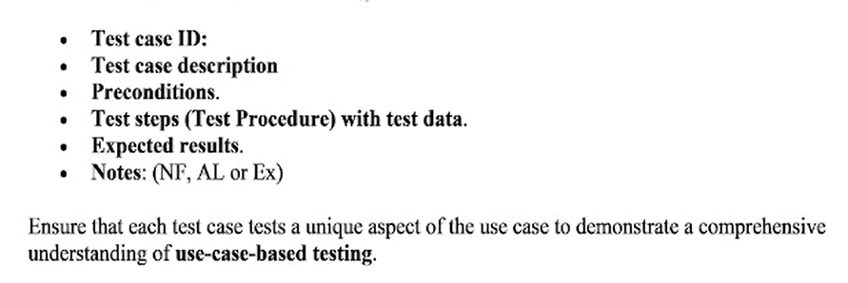

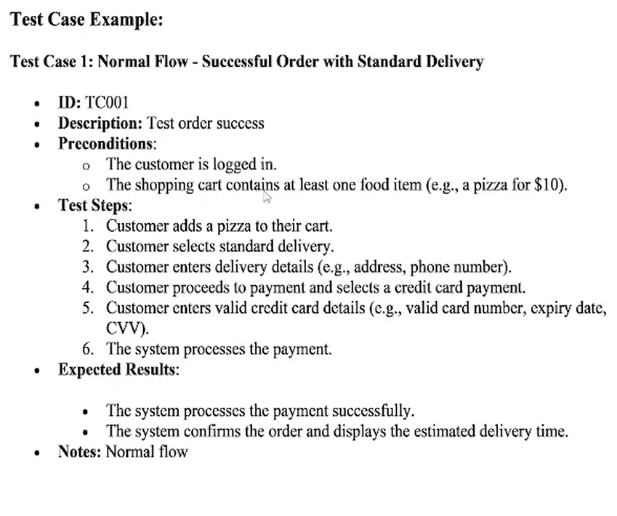

**Test Case ID: 002**

**Desciption: Checking order succesflly in case delivery= Express delivery**

**Pre-condition:**

**+ User has log into the system successfully**

**+ Shoping cart has at least one item**

**Test Steps:s**

**1. The customer adds pizza to their cart.**

**2. The customer selects a fast delivery**

**3. The customer enters delivery details (e.g., address, phone number).**

**4. The customer proceeds to payment and select card payment**

**5. Customer fill the valid card detail**

**6. The system processes the payment.**

**Expected Result:**

**- The system processes the payment successfully and add extra fee.**

**- The system confirms the order and display delivery time**

**Note: alternative Flow**

**Test Case ID: 003**

**Desciption: Test order with discount expired**

**Pre-condition:**

**+ User has log into the system successfully**

**+ Shoping cart has at least one item**

**Test Steps:s**

**1. The customer adds pizza to their cart.**

**2. The customer selects a delivery (normal)**

**3. The customer applies a expired discount code.**

**4. The system validate the discount code**

**Expected Result:**

**- The system display an error message**

**- The customer proceed to fill in the delivery details without a discount**

**Note: alternative Flow**

**Test Case ID: 004**

**Desciption: Test order with discount expired**

**Pre-condition:**

**+ User has log into the system successfully**

**+ Shoping cart has at least one item**

**Test Steps:s**

**1. The customer adds pizza to their cart.**

**2. The customer selects a delivery (normal)**

**3. The customer applies a expired discount code.**

**4. The system validate the discount code**

**Expected Result:**

**- The system display an error message**

**- The customer proceed to fill in the delivery details without a discount**

**Note: alternative Flow**